**Managing Hadoop Services**

**ls /etc/hadoop/conf**

Notice specifically the core-site.xml, hdfs-site.xml, and mapred-site.xml files. These files are some of the more commonly updated Hadoop configuration files

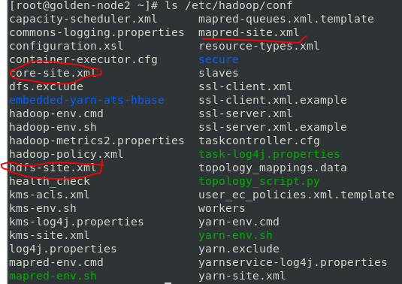



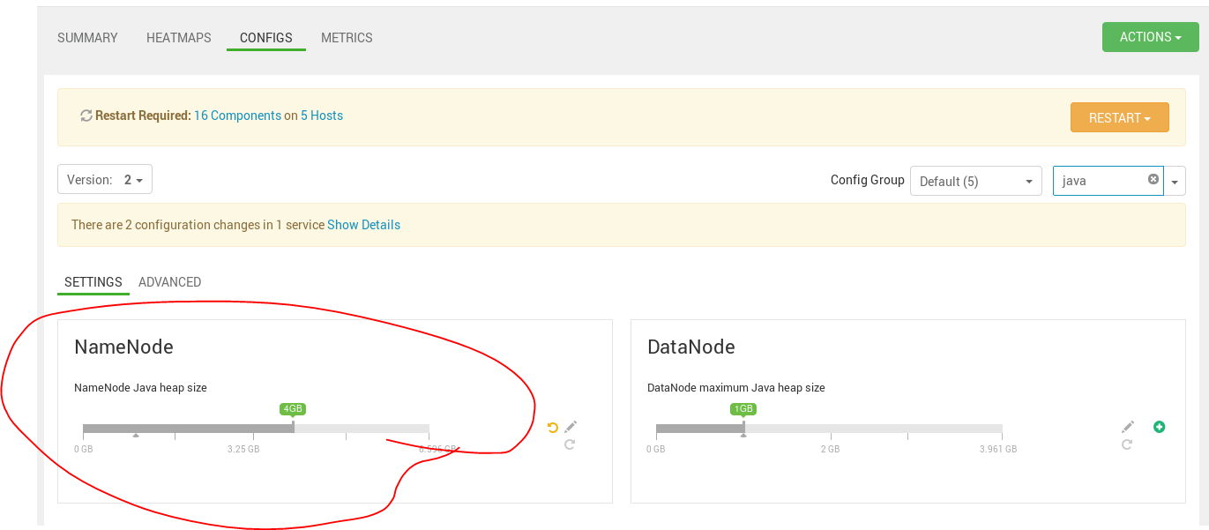

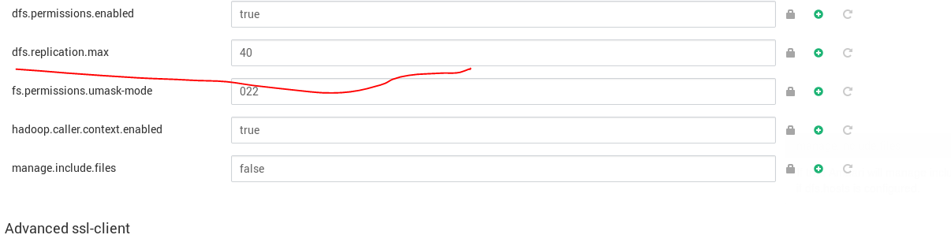

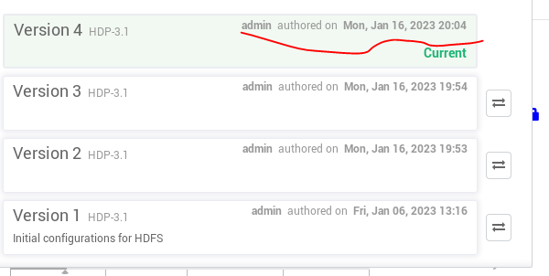

**Creating an Ambari Configuration Group**

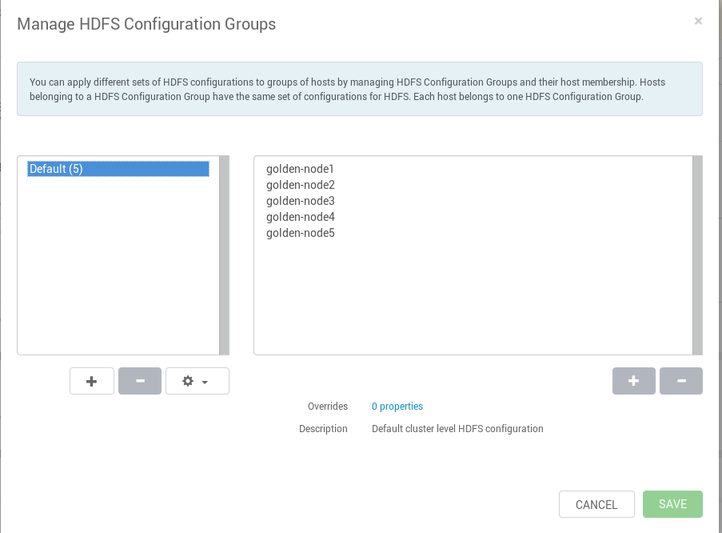

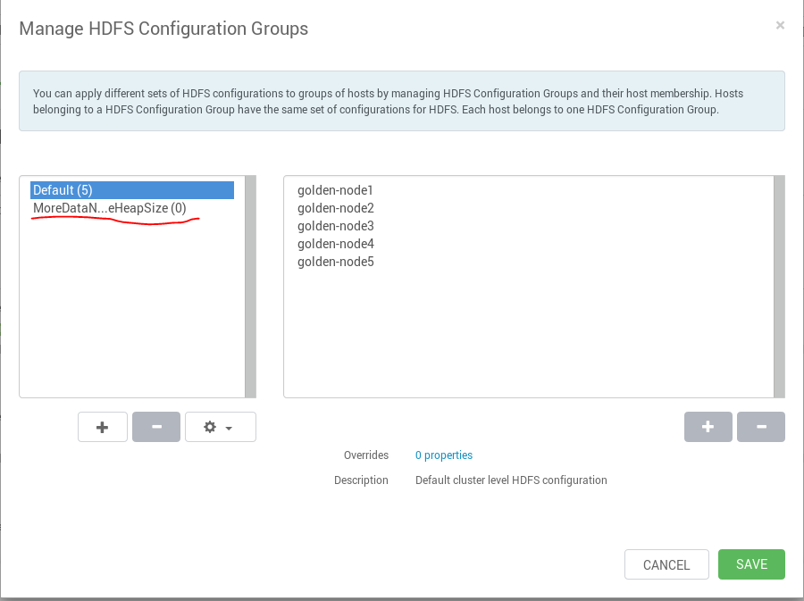

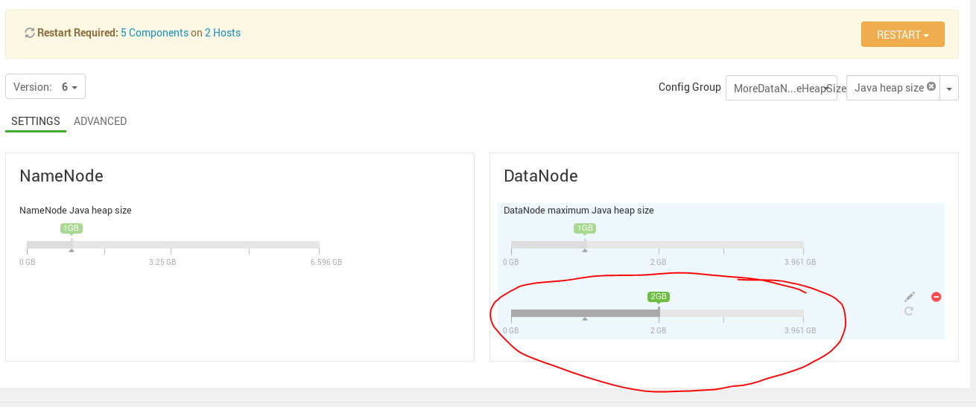

**Downloading HDFS Configuration Files**

**tar xvfz HDFS_CLIENT-configs.tar.gz**

